**FIRST ENGLISH EXAM UNITS 1, 2, 3, and 4 | CYCLE 2**

**Instruction: fill in the correct form of the verbs.**

1. They (to watch) ________ TV shows at night. **watch**
2. Manuel (to have) __________ a company in England. **has**
3. Karina (to fix) __________ computers efficiently. **fixes**
4. Kenneth (to study) _________ Programming and English. **studies**
5. Alberto (to program) __________ codes in java. **programs**

**Instruction: choose the best option that fits each statement.**

6. Andrew doesn’t like online books very much, so he ______ reads them.

* always
* generally
* rarely
* usually

**7.** Raphael __________ to use Python.

* don’t like
* doesn’t like
* don’t likes
* doesn’t likes

8. Brandon and Mary _______ here very often.

* don’t come
* doesn’t come
* doesn’t comes
* don’t comes

9. _____ do you usually go on holidays? I usually go to Italy.

* What
* Where
* Who
* When

**Instruction: fill in the blanks with “do” or “does”**

10. ______ your sister in law work on Saturdays? Does

11. ______ your parents give you a lot of money? Do

12. ______ we need our computer on Friday? Do

13. ______ your aunt know how to use this programming language? Does

**Instruction: observe the following image and choose the correct comparative or superlative form based on the given statement.**

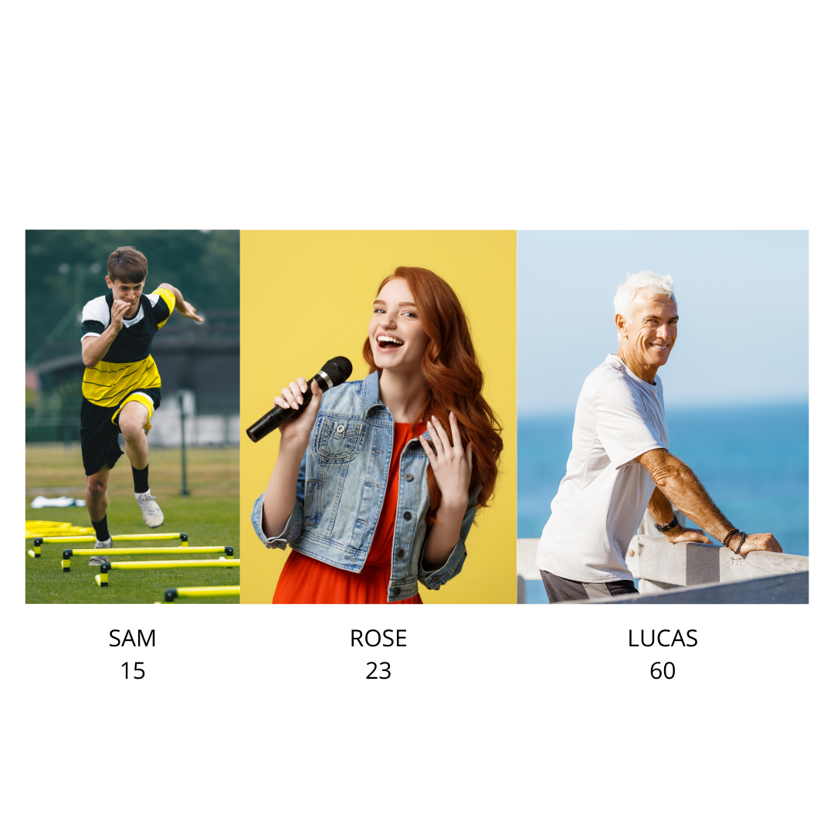

**14. Rose is _________ Lucas.**

1. **the oldest**
2. **younger than**
3. **older than**
4. **the youngest**

**15. Lucas is _________ Sam.**

1. **the youngest**
2. **the oldest**
3. **older than**
4. **younger than**

**16. Sam is __________**

1. **the youngest**
2. **the oldest**
3. **younger than**
4. **older than**

**17. Lucas is ___________**

1. **the oldest**
2. **older than**
3. **younger than**
4. **the youngest**

**Instruction: choose the correct modal verb to complete the sentences.**

**18. _________ I go to the bathroom?**

1. **May**
2. **Should**
3. **Must**

**19. She __________ eat too much chocolate. It’s not good!**

1. **must**
2. **could**
3. **shouldn’t**

**20. __________ you dance well?**

1. **Should**
2. **Must**
3. **Can**

**21. She _____ bring her passport or she won’t board the plane.**

1. **must**
2. **can**
3. **doesn’t have to**

**Instruction: read the sentence and choose the correct option.**

**22. Global warming will / is going to get worse.**

**23. If you are hungry, I will/ am going to make some pancakes.**

**24. What are / is your best friend going to do tomorrow?**

**25. I am not going to/ won’t help to cook.**

**26. I promise, I__________ the dishes when the movie finishes.**

**a. am going to wash**

**b. will wash**

**c. is going to washing**

**d. will to wash**

**27. We think, Alex ___________ classes next week.**

**a. isn’t going to have**

**b. won’t have**

**c. willn’t have**

**d. won’t is have**

**28. Monica and her husband ___________ to Argentina next summer.**

**a. is going to travel**

**b. are going to travel**

**c. will travel**

**d. are going travel**

**READING COMPREHENSION**

**TECHNOLOGY IS GETTING SMALLER**

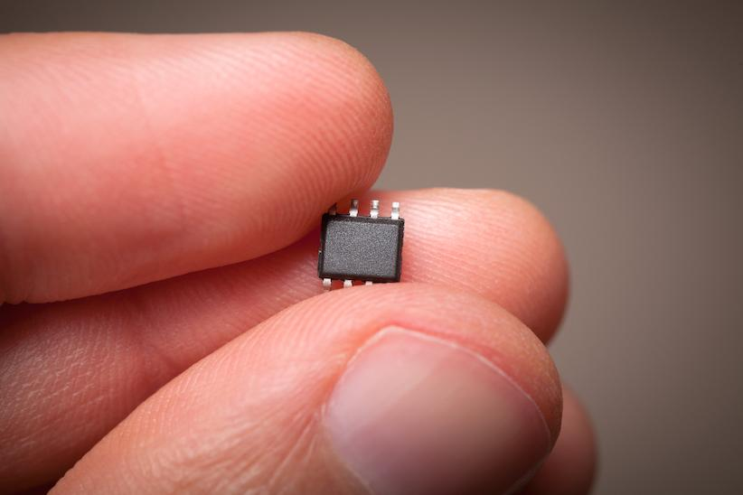

**CAMERAS**

The first cameras were very big. You couldn’t carry them around. They were also very expensive. Not many people could buy a camera.

Today we have cameras that we can carry around with us. They are also cheap. Today most cameras are digital. This means we can save thousands of photos on the camera’s memory card. We can also change the images.

**TELEPHONES**

The first telephone needed cables and electricity. You couldn’t move them around. The first phones without cables needed enormous batteries. They were used by the military, police and ambulance men. The first real mobile phone was also very big, with a big battery.

Now mobile phones are much smaller. They still use batteries and you have to charge them, but they can take photos and videos, and you can connect to the internet, and watch TV.

**MUSIC**

At first people listened to music on vinyl records. These were big and fragile. Then there were cassette tapes, and later there were CDs. Now you can put thousands of songs on an MP3 player and listen to your playlists wherever you are.

**Instruction: based on the text, you will have to read the sentences and choose** : **TRUE or FALSE.**

29. Were the first cameras small? TRUE FALSE

30. Can we save more photos on modern cameras than on the first cameras? TRUE FALSE

31. Could you carry the first telephone around? TRUE FALSE

32. Did the first mobile phone have a small battery? TRUE FALSE

33. Did vinyl records exist before cassette tapes? TRUE FALSE

34. Can you listen to a playlist anywhere today? TRUE FALSE