**Prueba de suficiencia de inglés**

**Nivel A2 - Beneficiarios Misión TIC 2022**

**CICLO 2**

**Instruction: For each statement, choose the correct option.**

1.



1. Daniel is selling the house because it’s too big for him.
2. There is a space for constructing a pool.
3. The house that is for sale, it’s in a rural area close to a river.

2.



1. Dave thinks Andres should look on the trip website.
2. Dave hopes that Andres will be able to come with him.
3. Dave wants to know if Andres can pay him back today.

3.



A. You can get into the park by going this path.

B. It is more expensive to go here alone.

C. You will have fun if you come with friends

4.



A. Bett knows that Chris can’t be at the party when it starts.

B. Bett wants to go to the party a bit later than Chris.

C. Bett wants to go out with Chris but not to the party.

5.



A. The coffee store is only open for 2 hours.

B. Two coffees will cost the same as one.

C. You can get free coffees all afternoon.

6.



Why did Camille write the message?

A. to check if Andrea has her complete equipment for next week.

B. to let Andrea know what they did in class today.

C. to ask Andrea to contact her about the training for next week.

***Instruction*: Read the sentences. Then, listen and choose the correct answer. You will hear the recording twice.**

**7. Sandy Thompson is an _______________.**

**animal expert**

**animal trafficker**

**8. An animal trafficker _______________ wild animals.**

**kills**

**sells**

**9. Animals are often sold in _______________.**

**natural habitats**

**foreign countries**

**10. Some people buy these animals _______________.**

**as exotic pets**

**to resell them**

**11. Some animals are used to _______________.**

**souvenirs**

**make clothes**

**12. Other animals are _______________ in restaurants.**

**eaten**

**sold**

**13. _______________ buy them in markets as souvenirs.**

**Tourists**

**Traffickers**

**14. Most trafficking occurs in countries with _______________.**

**a big problem**

**tropical climates**

**15. A lot of animals used in trafficking are _______________.**

**endangered**

**exotic birds**

**16. It’s a big problem for _______________.**

**traffickers**

**conservation**

**READING COMPREHENSION SECTION**

***Instruction*: Read the following text and answer the questions below.**

**Two Women Leaders in AI, Machine Learning and Robotics**

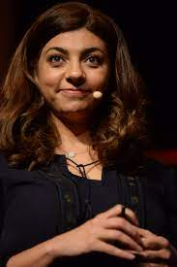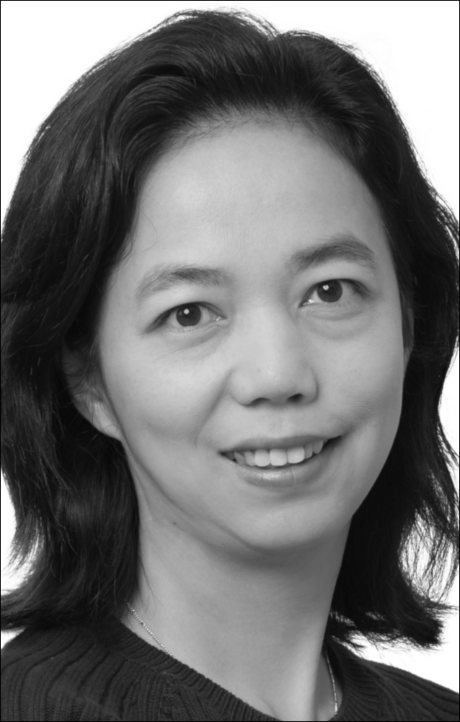

The age of artificial intelligence (AI), machine learning and robotics is here, and these technologies will keep on being part of our lives in the future. **However**, the people working in these fields still don’t reflect the society we are living in. Women make up only 22% of AI professionals worldwide, and in the more specialized area of machine learning, only 12% are women.

**[A]** AI and machine learning continue to be male-dominated fields. **[B]** But what would an artificially intelligent world designed by women look like? **[C]** By making AI more human, redesigning the construction industry and the healthcare sector, or promoting the human-robot interaction, there are many ways in which women can contribute to the world. **[D]**

**Rana el Kaliouby**

She’s the CEO of Affectiva, an American software company using AI technology to detect emotions through face and voice. She has led the development of Affectiva’s emotion AI technology, **which** employs computer vision, deep learning, machine learning and speech processing to recognize emotions from **vast** amounts of facial data. Before starting Affectiva, el Kaliouby worked as a research scientist at MIT Media Lab. She earned her PhD from the University of Cambridge and her post-doctorate at MIT.

El Kaliouby envisions a future where robots work with humans, not against them. “It may seem improbable, but I see AI in partnership with people, helping us do our jobs better. They may also contribute to making us healthier and happier.”

**Fei-Fei Li**

Li is one of the most brilliant minds in artificial intelligence. She’s currently a professor at Stanford University and co-heads the Stanford Human-Centered AI Institute (HAI), dedicated to advancing AI research and development for the good of humanity. Li has also had experience as a chief scientist at Google Cloud.

She promotes diversity and inclusion in AI as director of nonprofit organization AI4ALL. Li has received numerous awards for her work, including the 2017 Athena Award for Academic Leadership from the University of California. In a recent interview, Li talked about **her** vision for HAI: “I hope that we can create technologies that help humans live better and healthier and work more safely and productively.”

**17. The word “however” in paragraph number 1 is closer in meaning to:**

1. Consequently
2. Because
3. Also
4. But

**18. The word “which” in paragraph 3 refers to:**

1. technology
2. development
3. emotion
4. Affectiva

**19. What is NOT true about Fei-Fei Li?**

1. Her knowledge makes her a world expert on AI.
2. She’s one of the directors of the HAI.
3. Her work has never been recognized.
4. She supports the involvement of different people in AI.

**20. The word “her” in paragraph 6 refers to:**

1. Work
2. Interview
3. Li
4. California

**21. What does Fei-Fei Li do?**

1. She has a lower position at AI4ALL.
2. She studies at University of California.
3. She teaches at a University.
4. She works for Google.

**22. What can be inferred in paragraph 1?**

1. There should be more women working in the technology industry.
2. In total, 34% of technology workers are women.
3. Many women specialize in machine learning.
4. Artificial intelligence and robotics are new types of technologies.

**23. What is the objective of HAI?**

1. To sell their technology to Google.
2. To create technology to benefit humans.
3. To employ the best scientist in California.
4. To build brilliant robots.

**24. What is the Kaliouby attitude towards robots?**

1. She doesn’t believe they are so useful.
2. She doesn’t think robots could ever replace humans.
3. She is afraid of them.
4. She hopes humans and robots will interact more in the future.

**25. What is stated in paragraph 2?**

1. Involving more women in the AI field could bring great benefits.
2. More buildings can be constructed if AI is applied.
3. Humans could lose their jobs if AI keeps being developed.
4. Robots can be used in hospitals, especially for medical procedures.

**26. What is NOT stated about Rana el Kaliouby in paragraph 3?**

1. She works for a computer company.
2. She has a high position at Affectiva.
3. She was born in the US.
4. She has helped develop a type of AI technology.

Instruction: Read the information about Dinosaurs. Then, choose the best word (A, B or C) for each space.

DINOSAURS



No one has (27)_______ seen a dinosaur. The last dinosaur died about 60 million years ago a long time (28)_______ there were any people on the earth. (29)_______ knows for sure why they all died. The nearest living relatives of dinosaurs are birds.

Dinosaurs didn’t all look the same. There were more (30)_______ 5000 kinds. Some were very small, (31)_______ others were giants. The largest were bigger than any other animals that ever lived (32)_______ land. The Brontosaurus, for example, was twenty meters long, and it (33)_______ plants. The Tyrannosaurus Rex was not as (34)_______ but it was stronger. It had sharp teeth for eating meat. Also it could run fast (35)_______ it had long back legs.

27.

1. ever
2. never
3. yet

28.

1. that
2. when
3. before

29.

1. Everybody
2. People
3. Nobody

30.

1. than
2. that
3. as

31.

1. as
2. but
3. or

32.

1. in
2. on
3. at

33.

1. ate
2. eat
3. eats

34.

1. bigger
2. biggest
3. big

35.

1. that
2. because
3. where

BIBLIOGRAFIA

<https://eco.colombiaaprende.edu.co/evaluation-tools/>

Key English Test. 1. (2004). Cambridge Books for Cambridge Exams. Retrieved June 14th 2022.