Insertar lectura en plataforma

**Robots**

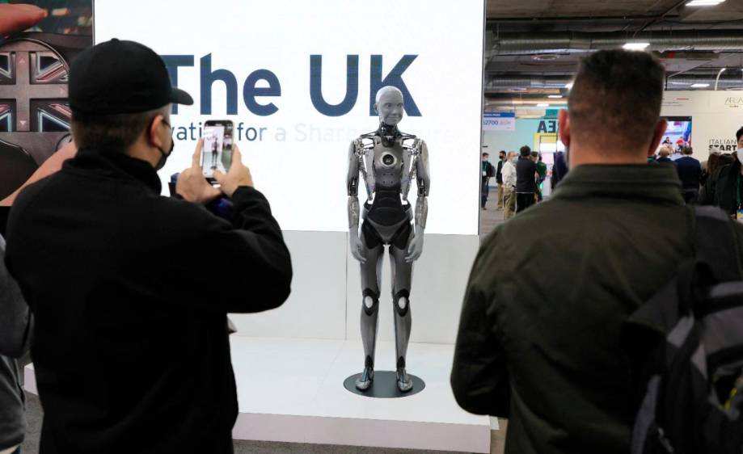

**Taken from: https://www.passporttoenglish.com**

When will we have robots?  We already have many kinds of robots!  Industries use a variety of robots and now robots are becoming more common in the home.

The Husqvarna company makes a lawn mowing robot called the Auto Mower.  The robot has sensors that detect where objects are in the yard and it maneuvers around them.  The robot can cut the grass while you relax on the patio with a glass of lemonade!  Also, Eureka now makes a robotic vacuum cleaner.  Like the robot lawn mower, the vacuum cleaner automatically detects where the furniture is and vacuums around it.

Cars are becoming robots now that many cars have GPS (Global Positioning Systems) on them.  A car with a GPS system can give you directions on how to go somewhere, tell you where the closest gas station is, and, some day in the future, will drive itself.  You will take a nap or read while the car drives itself to your destination.

We even have robotic pets now.  The Sony company makes a robotic dog named Aibo that can sit, stand, and walk like a regular dog but can also communicate and take pictures!  Aibo understands certain commands, like a dog does, such as "Sit down", "Stand up", "Turn right", etc.  If you ask Aibo a question such as "How old are you?", its eyes will flash the number of years old it is.  Aibo is also a great guard dog.  He can patrol the yard and take pictures with a built in camera of anything suspicious.

**Practice**

Select "True" or "False" to answer each question.

1. Principio del formulario
2. We have many kinds of robots now.
3. True
4. False

Final del formulario

Principio del formulario

1. The Auto Mower is a robot that vacuums.
2. True
3. False

Final del formulario

Principio del formulario

1. The Auto Mower has sensors that detect where objects are.
2. True
3. False

Final del formulario

Principio del formulario

1. Cars with GPS systems can give you directions.
2. True
3. False

Final del formulario

Principio del formulario

1. In the future cars will drive themselves automatically.
2. True
3. False

Final del formulario

Principio del formulario

1. Aibo is a robotic cat.
2. True
3. False

Respuestas:

1. True
2. False
3. True
4. True
5. True
6. False