**TYPES OF COMPUTERS**

**Glossary**:

- **Microprocessor**: A microprocessor is a component that performs the instructions and tasks involved in computer processing.

- **Input**: The act of putting information into a computer.

- **Operating system**: An operating system (OS) is system software that manages computer hardware, software resources, and provides common services for computer programs.

- **Touchpad**: The touchpad on a laptop does the same job as the mouse on a desktop PC. It is sometimes also called a trackpad. The touchpad is used to control the mouse pointer, also known as the cursor.

- **Touchscreen**: A touch screen is a display device that allows the user to interact with a computer by using their fingers.

***Instruction*:** Read the following text about computers. Then, choose the best option A, B, or C that better fits each statement.

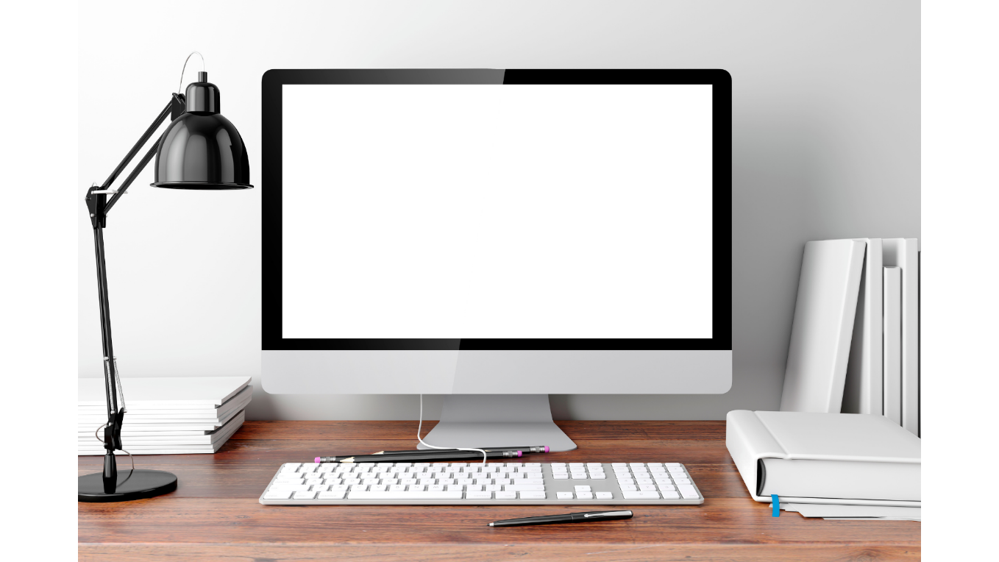

There are a lot of **terms** used to describe computers. Most of these words imply the size, expected use or capability of the computer. While the term computer can apply to virtually any device that has a **microprocessor** in it, most people think of a computer as a device that receives **input** from the user through a mouse or keyboard, then processes it, and displays the result on a screen.

**1. PC**

PC is a general term. The personal computer (PC) defines a computer designed for all-purpose use by a single person. While a Mac is a PC, most people **relate** the term with systems that run the Windows **operating system**. PCs were first known as microcomputers because they were a complete computer but built on a smaller scale than the huge systems in use by most businesses.

**2. Desktop**

A PC that is not designed for portability is a desktop computer. The expectation with desktop systems is that you will set the computer up in a permanent location. Most desktops offer more power, storage, and versatility for less cost than their portable version.

**3. Laptop**

Also called notebooks, laptops are portable computers that integrate the screen, keyboard, a pointing device or **touchpad** (incorporated mouse), processor, memory and hard drive. All this comes in a battery-operated package slightly larger than an average book.

**4. Tablet**

A tablet computer, commonly shortened to tablet, is a mobile device, typically with a mobile operating system and **touchscreen** display. It has a rechargeable battery in a single, thin, and flat package. Tablets do what other personal computers do, but they lack some input/output abilities that others have. Modern tablets largely resemble modern smartphones, the only differences being that tablets are relatively larger than smartphones, with screens 7 inches (18 cm) or larger.

**5. Workstation**

The fifth type of computer is a workstation. A workstation is simply a desktop computer that has a more powerful processor, additional memory and enhanced capabilities for performing a special group of tasks, such as 3D Graphics or game development.

*\*Adapted from https://computer.howstuffworks.com/10-types-of-computers.htm#pt10*

**ANSWERS:**

**1. A**

**2. C**

**3. B**

**4. C**

**5. B**

**6. C**

**7. B**

**8. A**

***Instruction*:** choose the best option A, B, or C that better fits each statement.

1. **In chapter 1, the best synonym for the word DEVICE is:**

a) Apparatus

b) Invention

c) Object

1. **In chapter 2, the best synonym for the word COMPLETE is:**

a) Defective

b) Undivided

c) Entire

1. **In chapter 3, the best synonym for the word PERMANENT is:**

a) Persistent

b) Long-lasting

c) Temporary

1. **In chapter 4, the best synonym for the word PORTABLE is:**

a) Unhandy

b) Big

c)Compact

1. **In chapter 5, the best synonym for the word LACK is:**

a) Sufficiency

b) Absence

c) Reduction

1. **In chapter 6, the best Antonym for the word POWERFUL is:**

a) Potent

b) Capable

c) Ineffective

1. **In chapter 1, the word TERM is:**

a) False cognate

b) True Cognate

C) Partial cognate

1. **In chapter 2, the word RELATE is:**

a) False cognate

b) True cognate

c) Partial cognate

1. **Match the descriptions with the type of computers:**

|  |  |  |  |
| --- | --- | --- | --- |
| **1** | **Pc** | **It’s a light computer you can take with you. It includes a mouse.** | **A** |
| **2** | **Desktop** | **It’s more sophisticated and has better components than a desktop.** | **B** |
| **3** | **Laptop** | **It’s bigger than a cellphone and you can control it with your fingers.** | **C** |
| **4** | **Tablet** | **It’s a standard name to refer computers.** | **D** |
| **5** | **Workstation** | **Bigger than a laptop and more efficient. You keep it at home.** | **E** |

**ASWERS:**

**1. D**

**2. E**

**3. A**

**4. C**

**5. B**