ACTIVITY #2

Crossword

Crossword activity related to the fundamentals of AI.
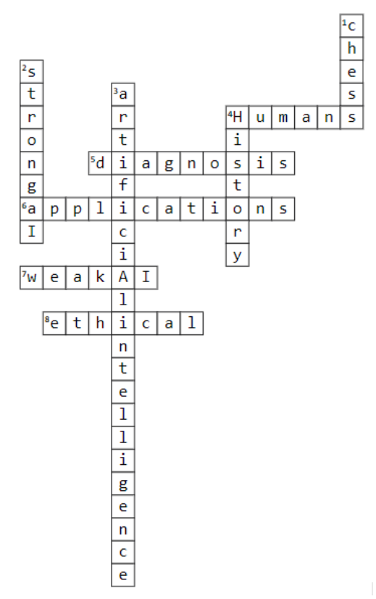
Across  4. The core of AI involves teaching computers to think and learn like ___________.  5. AI is used in a wide range of applications, from virtual personal assistants like Siri and Alexa to facial recognition technology, self-driving cars, and medical __________.  6. The ability of AI to transform many industries, from finance, and healthcare to manufacturing and transportation.  7. AI type designed for a specific task or set of tasks.  8. Concerns around issues like job displacement, bias in decision-making, and control over the technology. |  | Down  1. The first _____-playing computer program in 1951.  2. The main types of AI: narrow or weak AI and general or ___________.  3. The development of computer systems that can perform tasks requiring human intelligence.  4. AI has a long and fascinating ________, dating back more than 50 years.

