**ACTIVITY #4**

**Type of activity: WordSearch**

1. **Wordsearch about vocabulary related to edge computing.**

Search the word’s list in the letter-soup or click in the link below for a better experience:

**LINK:** [**https://wordwall.net/es/resource/67280218/edge-computing**](https://wordwall.net/es/resource/67280218/edge-computing)

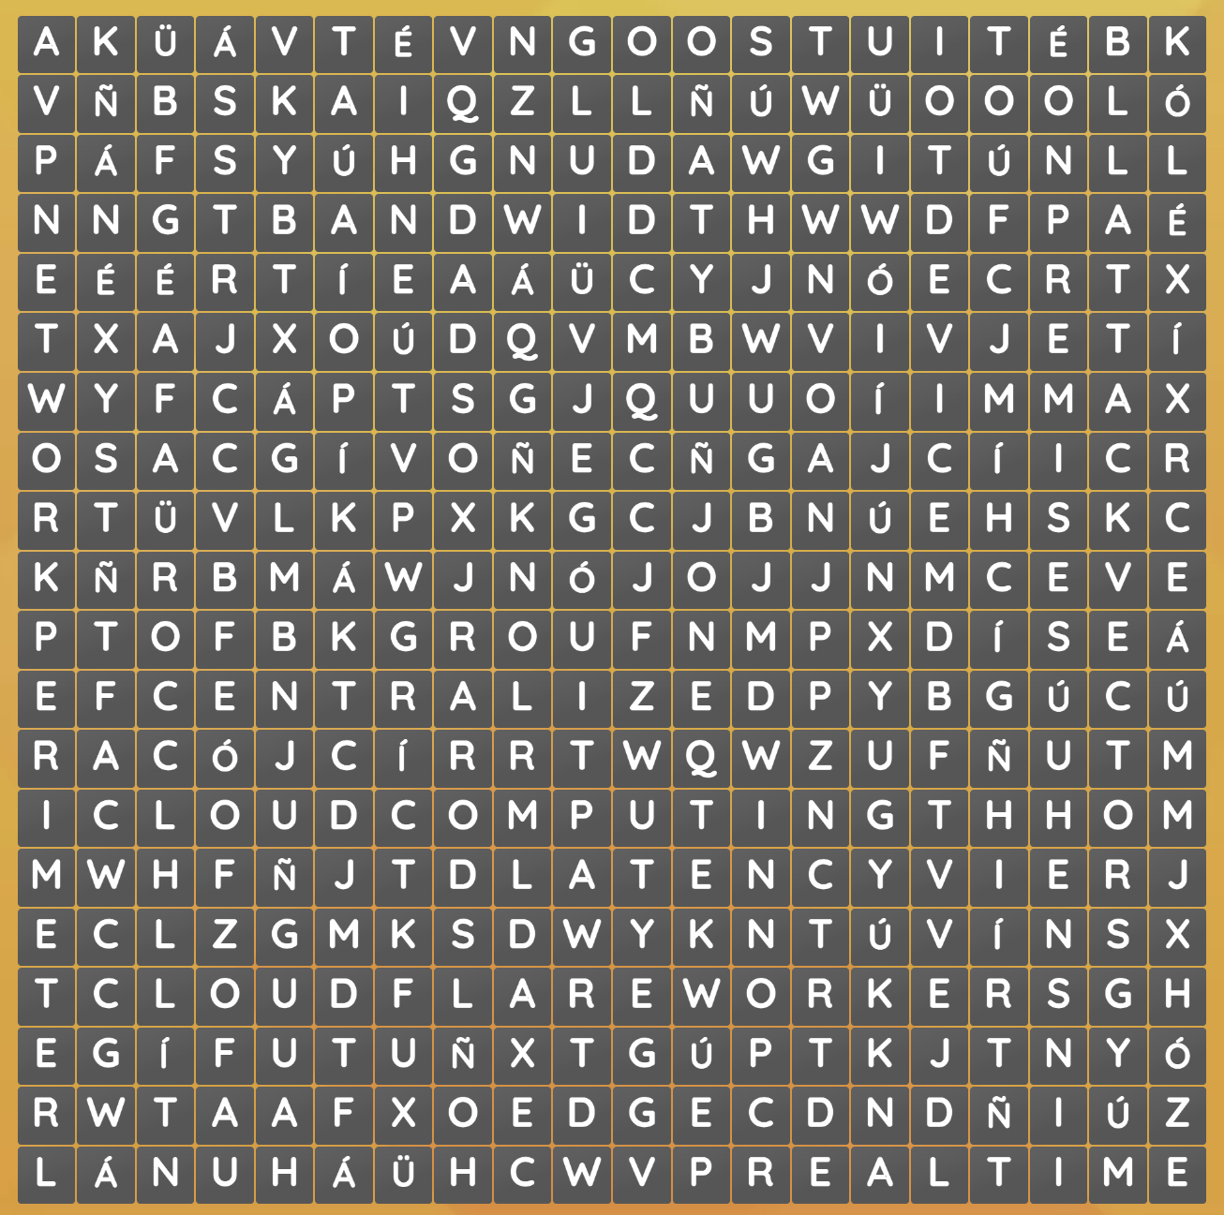

**LIST OF WORDS:**

Edge Computing.

Latency.

Bandwidth.

On-premises.

IoT Device.

Network Perimeter.

Cloud Computing.

Centralized.

Real-time.

Attack Vectors.

Edge CDN.

Cloudflare Workers.