**ACTIVIDAD #1**

**Tipo actividad: reading "P-Value: What It Is, How to Calculate It, and Why It Matters", multiple choice game**

**Socialize keywords of the reading "P-Value: What It Is, How to Calculate It, and Why It Matters"**

1. **P-Value:** A statistical measurement that assesses the probability of obtaining observed results, assuming the null hypothesis is true. It helps in determining the significance of a hypothesis test.

2. **Null Hypothesis:** The initial claim about a population or data-generating process that is being tested in a statistical hypothesis test. It often assumes no significant difference or effect.

3. **Statistical Significance:** The level of confidence in rejecting the null hypothesis based on the p-value. A lower p-value indicates greater statistical significance.

4. **Confidence Level:** The predetermined level of significance used to assess the statistical significance of the p-value. Different researchers may use different levels, leading to varied interpretations.

5. **Two-Tailed Test:** A type of hypothesis test where the alternative hypothesis considers the population parameter to be different from the value stated in the null hypothesis, either less than or greater than.

**12) Reading: "P-Value: What It Is, How to Calculate It, and Why It Matters"**

**P-Value: What It Is, How to Calculate It, and Why It Matters**

Learn why this is an important statistics calculation

**What Is P-Value?**

In statistics, the p-value is the probability of obtaining results at least as extreme as the observed results of a statistical hypothesis test, assuming that the null hypothesis is correct. The p-value serves as an alternative to rejection points to provide the smallest level of significance at which the null hypothesis would be rejected. A smaller p-value means that there is stronger evidence in favor of the alternative hypothesis.

P-value is often used to promote credibility for studies or reports by government agencies. For example, the U.S. Census Bureau stipulates that any analysis with a p-value greater than 0.10 must be accompanied by a statement that the difference is not statistically different from zero. The Census Bureau also has standards in place stipulating which p-values are acceptable for various publications.

**KEY TAKEAWAYS**

* A p-value is a statistical measurement used to validate a hypothesis against observed data.
* A p-value measures the probability of obtaining the observed results, assuming that the null hypothesis is true.
* The lower the p-value, the greater the statistical significance of the observed difference.
* A p-value of 0.05 or lower is generally considered statistically significant.
* 1
* P-value can serve as an alternative to—or in addition to—preselected confidence levels for hypothesis testing.

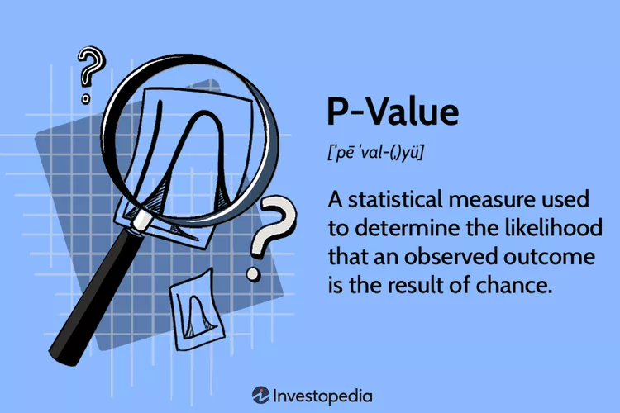

Jessica Olah / Investopedia

**How Is P-Value Calculated?**

P-values are usually found using p-value tables or spreadsheets/statistical software. These calculations are based on the assumed or known probability distribution of the specific statistic tested. P-values are calculated from the deviation between the observed value and a chosen reference value, given the probability distribution of the statistic, with a greater difference between the two values corresponding to a lower p-value.

Mathematically, the p-value is calculated using integral calculus from the area under the probability distribution curve for all values of statistics that are at least as far from the reference value as the observed value is, relative to the total area under the probability distribution curve.

The calculation for a p-value varies based on the type of test performed. The three test types describe the location on the probability distribution curve: lower-tailed test, upper-tailed test, or two-tailed test.

In a nutshell, the greater the difference between two observed values, the less likely it is that the difference is due to simple random chance, and this is reflected by a lower p-value.

**The P-Value Approach to Hypothesis Testing**

The p-value approach to hypothesis testing uses the calculated probability to determine whether there is evidence to reject the null hypothesis. The null hypothesis, also known as the conjecture, is the initial claim about a population (or data-generating process). The alternative hypothesis states whether the population parameter differs from the value of the population parameter stated in the conjecture.

In practice, the significance level is stated in advance to determine how small the p-value must be to reject the null hypothesis. Because different researchers use different levels of significance when examining a question, a reader may sometimes have difficulty comparing results from two different tests. P-values provide a solution to this problem.

For example, suppose a study comparing returns from two particular assets was undertaken by different researchers who used the same data but different significance levels. The researchers might come to opposite conclusions regarding whether the assets differ.

If one researcher used a confidence level of 90% and the other required a confidence level of 95% to reject the null hypothesis, and if the p-value of the observed difference between the two returns was 0.08 (corresponding to a confidence level of 92%), then the first researcher would find that the two assets have a difference that is statistically significant, while the second would find no statistically significant difference between the returns.

To avoid this problem, the researchers could report the p-value of the hypothesis test and allow readers to interpret the statistical significance themselves. This is called a p-value approach to hypothesis testing. Independent observers could note the p-value and decide for themselves whether that represents a statistically significant difference or not.

Even a low p-value is not necessarily proof of statistical significance, since there is still a possibility that the observed data are the result of chance. Only repeated experiments or studies can confirm if a relationship is statistically significant.

**Example of P-Value**

An investor claims that their investment portfolio’s performance is equivalent to that of the Standard & Poor’s (S&P) 500 Index. To determine this, the investor conducts a two-tailed test.

The null hypothesis states that the portfolio’s returns are equivalent to the S&P 500’s returns over a specified period, while the alternative hypothesis states that the portfolio’s returns and the S&P 500’s returns are not equivalent—if the investor conducted a one-tailed test, the alternative hypothesis would state that the portfolio’s returns are either less than or greater than the S&P 500’s returns.

The p-value hypothesis test does not necessarily make use of a preselected confidence level at which the investor should reset the null hypothesis that the returns are equivalent. Instead, it provides a measure of how much evidence there is to reject the null hypothesis. The smaller the p-value, the greater the evidence against the null hypothesis.

Thus, if the investor finds that the p-value is 0.001, there is strong evidence against the null hypothesis, and the investor can confidently conclude that the portfolio’s returns and the S&P 500’s returns are not equivalent.

Although this does not provide an exact threshold as to when the investor should accept or reject the null hypothesis, it does have another very practical advantage. P-value hypothesis testing offers a direct way to compare the relative confidence that the investor can have when choosing among multiple different types of investments or portfolios relative to a benchmark such as the S&P 500.

For example, for two portfolios, A and B, whose performance differs from the S&P 500 with p-values of 0.10 and 0.01, respectively, the investor can be much more confident that portfolio B, with a lower p-value, will actually show consistently different results.

**Is a 0.05 P-value Significant?**

A p-value less than 0.05 is typically considered to be statistically significant, in which case the null hypothesis should be rejected. A p-value greater than 0.05 means that deviation from the null hypothesis is not statistically significant, and the null hypothesis is not rejected.

**What Does a P-value of 0.001 Mean?**

A p-value of 0.001 indicates that if the null hypothesis tested were indeed true, then there would be a one-in-1,000 chance of observing results at least as extreme. This leads the observer to reject the null hypothesis because either a highly rare data result has been observed or the null hypothesis is incorrect.

**How Can You Use P-value to Compare Two Different Results of a Hypothesis Test?**

If you have two different results, one with a p-value of 0.04 and one with a p-value of 0.06, the result with a p-value of 0.04 will be considered more statistically significant than the p-value of 0.06. Beyond this simplified example, you could compare a 0.04 p-value to a 0.001 p-value. Both are statistically significant, but the 0.001 example provides an even stronger case against the null hypothesis than the 0.04.

**The Bottom Line**

The p-value is used to measure the significance of observational data. When researchers identify an apparent relationship between two variables, there is always a possibility that this correlation might be a coincidence. A p-value calculation helps determine if the observed relationship could arise as a result of chance.

**14) Multiple-choice game based on the previous reading.**

1. What does the p-value represent in a hypothesis test?

- A. The level of confidence

- B. Probability of obtaining observed results

- C. The significance level

- D. The population parameter

2. What is the purpose of the null hypothesis in hypothesis testing?

- A. To assert a significant difference

- B. To provide an initial claim about a population

- C. To determine statistical significance

- D. To set the confidence level

3. In a two-tailed test, how does the alternative hypothesis differ from the null hypothesis?

- A. Assumes no significant difference

- B. Considers the population parameter to be different

- C. Tests for equality

- D. Sets the confidence level

4. What does a p-value less than 0.05 typically indicate?

- A. Statistical insignificance

- B. Rejection of the null hypothesis

- C. Confidence level

- D. Null hypothesis acceptance

5. How can researchers address the issue of different significance levels in hypothesis testing?

- A. Use preselected confidence levels

- B. Report only confidence intervals

- C. Rely on p-value comparisons

- D. Avoid hypothesis testing altogether