**ACTIVIDAD #3**

**Tipo actividad: Reading comprehension: “11 Big Data Trends You Must Follow in 2024" and related activities**

**Socialization of key vocabulary about trends in big data.**

1. **Machine Learning:** A field of artificial intelligence that focuses on developing algorithms allowing computers to learn from data and make predictions or decisions without explicit programming.

2. **Data Breaches:** Unlawful access to sensitive information, leading to its disclosure or theft, often causing harm to individuals or organizations and necessitating a focus on enhanced security measures.

3. **Predictive Analytics:** The use of statistical algorithms and machine learning techniques to analyze current and historical data, making predictions about future events, trends, or behaviors.

4. **Cloud Adoption:** The increasing use of cloud computing services to store, manage, and process data, providing benefits such as cost reduction, improved efficiency, and reliance on external services for security.

5. **Advanced Big Data Tools:** Utilization of sophisticated tools, including artificial intelligence and machine learning, to handle and analyze big data effectively, leading to more profound insights and improved data management.

**10) Reading comprehension activity: “11 Big Data Trends You Must Follow in 2024"**

**11 Big Data Trends You Must Follow in 2024**

In the rapidly evolving landscape of information technology, staying ahead of current big data trends is a must for organizations seeking to harness the power of data-driven insights. From transformative technologies to shifting paradigms in analytics, the world of big data management is witnessing dynamic trends that are reshaping how businesses operate and innovate.

There are certain steps for organizations to implement to overcome these barriers including applying best practices for managing big data, having a deeper understanding of its components, and train employees on the 3 V’s of big data.

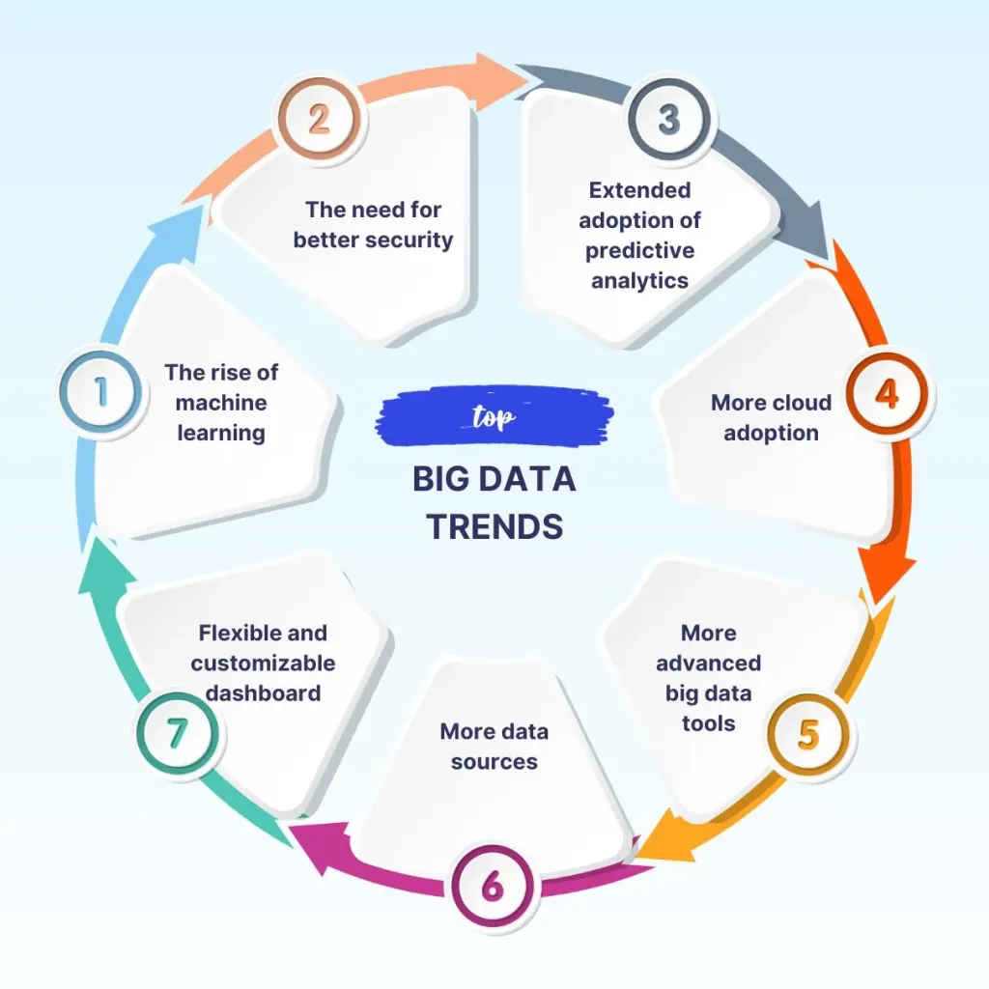

The big data trends in 2024 are:

**Trend #1- The rise of machine learning**

Machine learning has been around for a while, but it is only now that we are starting to see its true potential. It’s not just about artificial intelligence anymore, but rather about how computers can learn from their own experience and make predictions on their own.

It is the most important part of big data analytics because it can process and analyze huge amounts of data in a short amount of time. It does this by using algorithms that are trained to recognize patterns in your data and then use those patterns to make predictions about what will happen next.

**Trend #2- The need for better security**

Data breaches have become more common than ever before and there’s no sign that they’ll stop happening anytime soon. Organizations need to invest heavily in security if they want to stay ahead of the curve.

During the third quarter of 2022, internet users worldwide saw approximately 15 million data breaches, up by 167 percent compared to the previous quarter as per statista.

Businesses are placing a high value on this topic because if their customers’ sensitive data is disclosed to the public without their consent, it would harm their brand and jeopardize their ability to retain consumers.

**Trend #3- Extended adoption of predictive analytics**

Predictive analytics is on the rise and is considered among the top benefits of big data even though this topic isn’t new. Looking at data as the most valuable asset, organizations will widely use predictive analytics in order to understand how customers reacted and will react to a specific event, product, or service including predict future trends.

For example, these systems are used in a wide range of fields for tasks such as identifying credit card fraud or predicting which customers are likely to default on their loans.

**Trend #4- More cloud adoption**

Organizations can greatly benefit from moving to the cloud since it enables them to cut costs, increase efficiency, and rely on outside services to address security concerns. One of the most important big data trends is to keep pushing for further cloud migration and decreased reliance on on-premises data centers.

The only thing we need to keep an eye on is if businesses that handle extremely sensitive data will put greater faith in the cloud. This question may cause a significant change in the cloud.

**Trend #5- More advanced big data tools**

In order to handle big data properly and get the most out of it, organizations need to adopt advanced tools that are investing in cognitive technologies such as Artificial Intelligence and Machine Learning in order to facilitate its management and help them get more insights.

Business intelligence software companies are making significant investments in their technology in order to offer more potent tools that will fundamentally alter the way that big data is handled. The global market will be able to adopt and use big data projects as a result.

**Trend #6- Data lakes**

Data lakes are a new type of architecture that is changing the way companies store and analyze data. Historically, organizations would store their data in a relational database. The problem with this type of storage is that it is too structured to store all types of data such as images, audio files, video files and more. Data lakes allow organizations to keep all types of data in one place.

**Trend #7- More data sources (IoT, smart devices, generativeAI)**

There are many different ways that we can now collect data including sensors, generativeAI, social media platforms, and even smart devices.

With every technology introduction to the mass market, we should expect more data to be generated thus increasing the challenges of managing big data from new sources. However once done properly, these data might help organizations better serve their clients and improve their business model.

This will continue to be one of the hottest big data trends for years to come.

**Trend #8- Data Fabric**

In hybrid multi-cloud systems, a data fabric is a framework and collection of data services that standardize big data best practices and offer consistent functionality.

Data Fabric provides the ability to share data across different platforms and applications without the need for any additional third party tools or software. It can be used as an alternative to traditional Hadoop clusters or as a complementary tool for storing large amounts of unstructured data in an easy-to-access manner.

**Trend #9- Data Quality**

As more businesses rely on data to make intelligent business decisions, they must ensure that the data they use is of a high quality. Poor data quality will force your company to make poor business decisions, provide poor insights, and hinder its capacity to comprehend its clients.

Although data quality can be challenging, there are a number of approaches that businesses can use to gain from high-quality data. The future of big data depends on how organizations can assess the quality of their data.

**Trend #10- Flexible and customizable dashboard**

One of the major developments in big data is the end of predefined dashboards that meet the needs of all employees because data might be viewed differently by employees in different departments.

In order to make the most of their data, employees will soon be able to build and interact with it anyway they see fit. It has become easier for non-technical individuals to design their own dashboards and examine a portion of data that makes sense to them using straightforward and imaginative tools.

**Trend #11- More restricted data governance**

There are many reasons for the future to hold a more restrictive data governance. The first one is the need for data protection and privacy regulations.

Secondly, there is a growing demand for data-driven decision making which requires more transparency around data.

Thirdly, there is the need to comply with global regulations and laws on data-related topics.

Fourthly, there are people who already have their own ideas of how they want to use their personal information and they don’t want to share it with anyone else.

**11) Multiple-choice questions about the previous reading.**

1. What is the primary focus of Trend #1 in the big data trends for 2024?

- A. Enhanced Security

- B. Cloud Migration

- C. Machine Learning

- D. Predictive Analytics

2. Why do organizations emphasize better security, as mentioned in Trend #2?

- A. To boost cloud adoption

- B. Due to an increase in data breaches

- C. To promote data quality

- D. For flexible and customizable dashboards

3. What is the purpose of Data Lakes, as discussed in Trend #6?

- A. To facilitate machine learning

- B. To store structured data only

- C. To store all types of data in one place

- D. To standardize big data best practices

4. What characterizes Trend #8, Data Fabric, in the big data trends?

- A. Increased reliance on on-premises data centers

- B. More advanced big data tools

- C. Adoption of a framework for standardizing data practices

- D. Development of flexible and customizable dashboards

5. Why is Data Quality highlighted in Trend #9?

- A. To encourage cloud migration

- B. To enable machine learning

- C. To ensure intelligent business decisions

- D. To restrict data governance

**12) Matching heading activity.**

**Column A: Headings**

1. Machine Learning Advancements

2. Heightened Concerns for Data Security

3. Growing Importance of Predictive Analytics

4. Embracing Cloud Solutions

5. Evolution of Data Storage with Data Lakes

**Column B: Definitions**

A. Trend #1- The rise of machine learning

B. Trend #2- The need for better security

C. Trend #3- Extended adoption of predictive analytics

D. Trend #4- More cloud adoption

E. Trend #7- Data lakes