**ACTIVITY #2**

**Type of activity: Jeopardy**

**Create a game from the articles provided.**

**Technology and Climate Change Jeopardy**

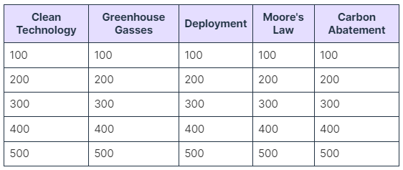

**Questions:**

**Clean Technology**

100 points: What is the primary goal of clean technology?

200 points: Give an example of a clean technology that can help reduce environmental impact.

300 points: How does clean technology contribute to sustainability efforts?

400 points: Explain how clean technology differs from traditional technology.

500 points: Discuss the importance of investing in clean technology for combating climate change.

**Greenhouse Gasses**

100 points: Name one greenhouse gas and its impact on the Earth's atmosphere.

200 points: How do greenhouse gases contribute to the greenhouse effect?

300 points: What are some sources of greenhouse gas emissions?

400 points: Explain the role of methane in global warming.

500 points: How can reducing greenhouse gas emissions help mitigate climate change?

**Deployment**

100 points: Define deployment in the context of technology and innovation.

200 points: What are some challenges associated with the large-scale deployment of new technologies?

300 points: Give an example of a successful deployment of a technology to address climate change.

400 points: Discuss the benefits of widespread deployment of clean energy solutions.

500 points: How can governments promote the deployment of sustainable technologies on a large scale?

**Moore's Law**

100 points: Who is credited with formulating Moore's Law?

200 points: Explain the significance of Moore's Law in the field of technology.

300 points: How has Moore's Law impacted the development of computer hardware?

400 points: Discuss any potential challenges or limits to Moore's Law in modern computing.

500 points: Predict how future advancements in technology may align with or diverge from Moore's Law.

**Carbon Abatement**

100 points: What is the main goal of carbon abatement strategies?

200 points: How do carbon capture and storage technologies contribute to carbon abatement?

300 points: Discuss the role of renewable energy sources in carbon abatement efforts.

400 points: Explain the concept of carbon offsetting and its importance in tackling climate change.

500 points: How can individuals and industries collaborate to achieve effective carbon abatement goals?